pohStiurF
pohStiurF is a fruit shop that is known globally for it’s cheap price and high quality fruits. Ms Chen wanted to make a program that help employees to sell fruits. Gner her son is will give you several requirement to make the program. You as a professional Phyton programmer must fulfill the clients request. The application has the following requirements :
The application consists of 4 menus:
- View Fruits
- Insert Fruits
- Remove Fruits
- Exit
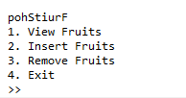
Figure 1. Main Menu
- If the user chooses menu 1 (“View Fruits”), the application will:
  - If there are no fruits in the list, show “No fruits to be viewed!”.
  - Jika tidak ada buah dalam daftar, tunjukkan “Tidak ada buah untuk dilihat!”.
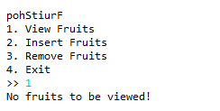
Figure 2. View Empty List
  - Otherwise, show all fruits in the list in ascending order (Sort by Fruits Name).
  - Jika tidak, tunjukkan semua buah dalam daftar dalam urutan naik (Sortir berdasarkan Nama Buah). Jika tidak, tunjukkan semua buah dalam daftar dalam urutan naik (Sortir berdasarkan Nama Buah).
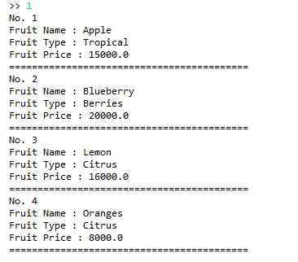
Figure 3. View All List
- If the user chooses menu 2 (“Insert Fruits”), the application will:
  - Validate that the list must not exceed 5 fruits.
  - Ask the user to input Fruits Name. Validate the name must be between 3 and 15 characters.
  - Ask the user to input Fruits Type. Validate the type must be either “Citrus”, “Berries” or “Tropical” case sensitive.
  - Ask the user to input Fruits Price. Validate that the price must be multiple of 1000.
  - Insert the new fruits to the list..
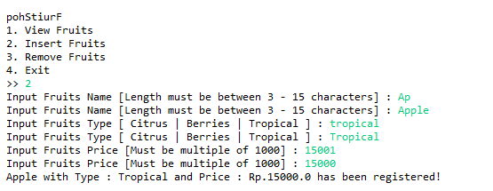
Figure 4. Insert Fruits
- If the user chooses menu 3 (“Remove Fruits”), the application will:
  - If there are no fruits in the list, show “No Fruits to be deleted!”.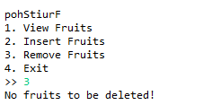
Figure 5. Delete Empty List
  - Show all available fruits in ascending order (Sort by Name) then ask user to input the fruits number to be deleted. Validate that the input must be between 1 and total fruits.
  - Tunjukkan semua buah yang tersedia dengan urutan menaik (Sort by Name) kemudian minta user untuk memasukkan nomor buah yang akan dihapus. Validasi bahwa masukan harus antara 1 dan total buah.
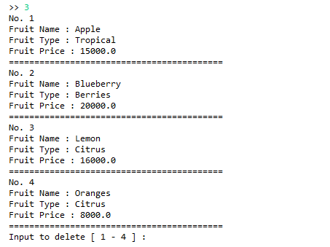
Figure 6. Delete List
  - After the user inputted the number, the application will generate random numeric captcha ranging from 100 to 1000 and will ask the user to re-input the captcha. Validate the user input must be the same as the generated captcha.
  - After that, delete the selected fruit from the list.
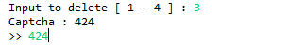
Figure 7. Captcha Verification
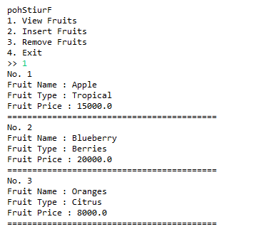
Figure 8. After Delete
- If user chooses menu 4 (“Exit”), the application will exit..

